MULTILINGUAL STORY GENERATION AND SPEECH SYSTEM
Conclusion, Future Scope and References
Department of Computer Science and Engineering, TKR College of Engineering & Technology
Batch C2 (CSE-C) · Academic year [ACADEMIC YEAR]
Table 1: Project team
S.No. | Student name | Roll number
1 | Lingala Sindhu | 23K91A05D3
2 | Padige Ajay | 23K91A05H8
3 | Mahek Ansari | 23K91A05D8
4 | Maheshwaram Hari Krishna | 23K91A05D9

Project guide: A Tejaswini
Chapter and section numbers quoted in the text (for example Chapter 8 or Section 6.2) refer to the full project report, 17.Final Document. Figures and tables in this document are numbered from 1.

1. CONCLUSION

1.1 Summary
StoryVox is a working local application that turns a story idea into a stored story and a spoken recording, behind an 11-route API and a five-page interface, using only pretrained models. Measured on 150 FLEURS sentences and 51 generated stories, the honest outcome is split: the narration stage is fast and, for 12 languages, clear; the story stage mostly answers in English whatever language is requested, and the application does not tell the user.

1.2 Objectives against outcomes
Table 2: Objectives against outcomes
Objective | Outcome | Evidence
1 Accept a user prompt | Achieved | Studio form, 2,000-character limit, server validation
2 Generate a story with length and reading-level controls | Partly | 3 lengths and 8 styles; no reading-level control
3 Translate into target languages | Not implemented | No translation module; requested language reached in 3 of 17 (shipped) and 8 of 17 (chat template) requests
4 Convert to speech | Achieved for 12 languages | MMS narration, mean RTF 0.247, mean CER 0.088; Italian by an English voice; Chinese and Japanese mostly silent
5 Playback with adjustable voice, speed and language | Partly | Player and download; language at generation time; no voice or speed control
6 Evaluate through user rating | Partly | Automated evaluation; WER and CER fail on story audio in the page; no user rating

1.3 Key findings
1. The speech half works. Twelve languages are narrated by MMS at a mean RTF of 0.247, and read back with a mean normalised CER of 0.088 and WER of 0.250; English gives WER 0.206 and CER 0.091. Spanish is best (CER 0.021) and Hindi weakest (CER 0.179).
2. The story half is the bottleneck. With the shipped prompt, 3 of 17 stories came out in the requested language; the chat template gets 8 of 17 at the same speed. Titles are often Untitled Story, and instruction text sometimes appears in the story.
3. Language mismatch destroys narration. English text read by the Hindi, French, German or Spanish voice gives WER 0.60 to 1.34, and the Hindi voice produced 4.4 s of audio for 185 words; English stories with an English voice give WER 0.25 and CER 0.21.
4. Three advertised languages are not delivered. Italian is read by an English voice (WER 0.49); Chinese (2 of 10) and Japanese (1 of 10) sentences produced any audio on the test machine.
5. The product does not report its own failures. The Evaluation page shows no WER or CER for any real story because the recogniser call fails beyond 30 seconds, and nothing on screen says that a story is in the wrong language.
6. It is fast enough for a local tool. A Short story takes 37 s, Medium 60 s and Long 80 s from request to finished narration on a CPU; the web layer adds a few milliseconds.
The abstract's claims about translation into target languages, adjustable voice and speed and evaluation through user rating are not demonstrated and are not claimed here.

1.4 Closing remark
The project's value is a measured, reproducible pipeline and a precise list of what to repair. With a chat-template prompt, a language check on the generated text, the three missing speech checkpoints replaced and chunked recognition on the Evaluation page, the same code would be a sound base for the multilingual storyteller the batch set out to build.
The measurements behind the key findings are shown below: the round-trip error of the narration in every language, and how the three story paths compare. The base paper evaluates translation quality with BLEU on different data, so no score in these figures can be set against it.
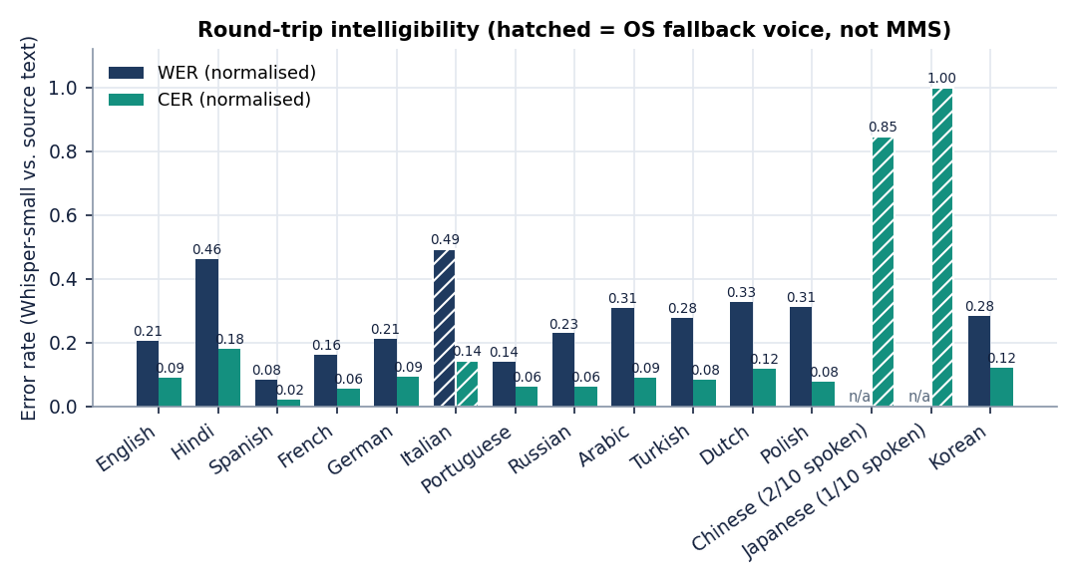
Figure 1: Round-trip WER and CER per language (Whisper-small transcript against the source text).
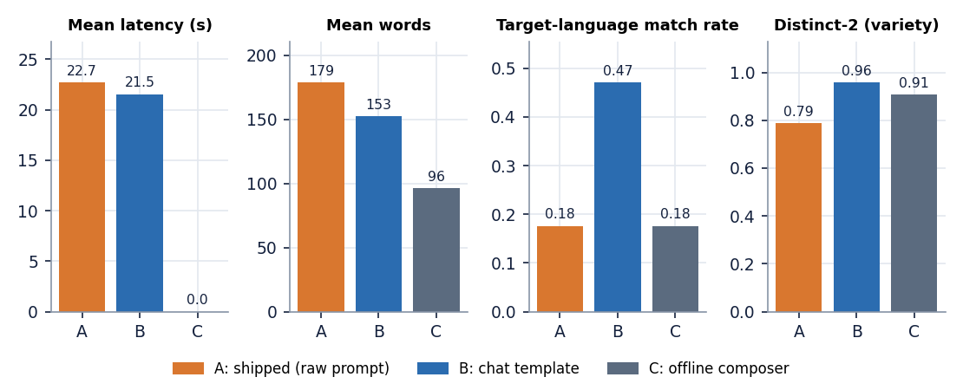
Figure 2: Story paths compared: shipped prompt (A), chat-template variant (B), offline composer (C).

2. FUTURE SCOPE

2.1 Repair the weaknesses found
• Prompt with the chat template. In the experiment, only the template changed and the language match rose from 3 to 8 of 17, instruction echo fell from 0.097 to 0.006 and variety rose.
• Check the language of the story with a detector and retry or fall back when it is wrong, and warn the user on screen.
• Chunk the recogniser (chunk_length_s=30) so the Evaluation page shows WER and CER, and load the similarity model once.
• Declare `ffmpeg` and `uroman`, rebuild the virtual environment with the supported Python, and replace the three missing MMS checkpoints with ones that exist or tell the user the language is narrated by a system voice.

2.2 Add features
• Translation of a story into another language, and a mode that narrates a user-supplied story.
• Voice, speaker and speed selection, the missing part of objective 5; reference-audio voices as in zero-shot systems [26], [6].
• Reading-level and style controls beyond the eight styles, and an age-appropriateness check, in the spirit of child-friendly multilingual generators [7].

2.3 Data, methods and deployment
• Compare Qwen3-0.6B with larger or storytelling-specific models [19] on the same 17 requests, and test a GPU.
• Collect human ratings of coherence and naturalness and measure Whisper's own error on natural speech.
• Add a job queue and progress reporting, authentication and a packaged installer.
The order matters: the repairs in the first group are small and testable, and they should be done before any new feature, because every later stage builds on a story that is in the language the user asked for.
Table 3: Roadmap
Stage | Work | Done when
1. Repair what was measured | Chat-template prompt; a language check with a retry or the composer; chunked recognition; declare ffmpeg and uroman; parse bold titles; replace or remove the three missing checkpoints | The 17-request experiment gives a language match well above 8 of 17 and the Evaluation page shows WER and CER for a story
2. Add what the objectives asked for | Voice and speed controls, reading level, a translate-then-narrate mode, user rating | A user can change speed and rate a story
3. Evaluate with people | Rate coherence and naturalness with a small panel; measure Whisper's own error floor | Ratings and a recogniser-error baseline are in the report
4. Scale and deploy | A larger story model or a GPU, a job queue, accounts, packaging | Several users can generate at once

3. REFERENCES
[1] C. Tran and S. Sakti, "SAM Translator: Self-paced learning and mixture-of-experts for cross-lingual text-to-speech translation," IEEE Access, vol. 14, pp. 2742-2752, 2026, doi: 10.1109/ACCESS.2025.3644647.
[2] "AI-based multilingual story generation and speech synthesis system," International Journal of Data Science and IoT Management System, 2026 (title as listed in the batch literature survey; not located online and not quoted).
[3] J. Park and K. Nakamura, "EmoSSLSphere: Multilingual emotional speech synthesis with spherical vectors and discrete speech tokens," in Proc. 13th ISCA Speech Synthesis Workshop (SSW), 2025, arXiv:2508.11273.
[4] "Multilingual text-to-speech system for programming languages using RAG and neural speech synthesis," Progressive Computational Intelligence, Information Technology and Networking, 2026 (title as listed in the batch literature survey; not located online and not quoted).
[5] "Vividtalker: Improving zero-shot text-driven motion generation in the framework of speech-text-guided motion synthesis," 2025 (title as listed in the batch literature survey; not located online, appears to concern motion synthesis, and is not quoted).
[6] H. Zhu, L. Ye, W. Kang, Z. Yao, L. Guo, F. Kuang, Z. Han, W. Zhuang, L. Lin and D. Povey, "OmniVoice: Towards omnilingual zero-shot text-to-speech with diffusion language models," arXiv:2604.00688, Apr. 2026.
[7] X. Gao, H. Zhang and N. F. Chen, "MultiGen: Child-friendly multilingual speech generator with LLMs," in Companion Proc. 27th Int. Conf. Multimodal Interaction (ICMI Companion '25), Canberra, Australia, Oct. 2025, doi: 10.1145/3747327.3764897.
[8] S. Arif, M. S. Haroon, A. J. Khan, T. Arif, A. A. Raza and A. Athar, "Kahaani: A multimodal co-creative storytelling system," arXiv:2409.11261, 2024 (rev. Feb. 2026).
[9] J. Kim, J. Kong and J. Son, "Conditional variational autoencoder with adversarial learning for end-to-end text-to-speech," in Proc. 38th Int. Conf. Machine Learning (ICML), PMLR vol. 139, Jul. 2021, pp. 5530-5540.
[10] V. Pratap et al., "Scaling speech technology to 1,000+ languages," Journal of Machine Learning Research, vol. 25, no. 97, pp. 1-52, 2024.
[11] A. Radford, J. W. Kim, T. Xu, G. Brockman, C. McLeavey and I. Sutskever, "Robust speech recognition via large-scale weak supervision," in Proc. 40th Int. Conf. Machine Learning (ICML), PMLR vol. 202, 2023, pp. 28492-28518.
[12] A. Yang et al., "Qwen3 technical report," arXiv:2505.09388, May 2025.
[13] N. Reimers and I. Gurevych, "Sentence-BERT: Sentence embeddings using Siamese BERT-networks," in Proc. Conf. Empirical Methods in Natural Language Processing and 9th Int. Joint Conf. Natural Language Processing (EMNLP-IJCNLP), 2019, pp. 3982-3992.
[14] N. Reimers and I. Gurevych, "Making monolingual sentence embeddings multilingual using knowledge distillation," in Proc. Conf. Empirical Methods in Natural Language Processing (EMNLP), 2020, pp. 4512-4525.
[15] C.-Y. Lin, "ROUGE: A package for automatic evaluation of summaries," in Text Summarization Branches Out, Proc. ACL-04 Workshop, Barcelona, Spain, 2004, pp. 74-81.
[16] A. Conneau, M. Ma, S. Khanuja, Y. Zhang, V. Axelrod, S. Dalmia, J. Riesa, C. Rivera and A. Bapna, "FLEURS: Few-shot learning evaluation of universal representations of speech," in Proc. IEEE Spoken Language Technology Workshop (SLT), 2022, arXiv:2205.12446.
[17] T. Wolf et al., "Transformers: State-of-the-art natural language processing," in Proc. Conf. Empirical Methods in Natural Language Processing: System Demonstrations (EMNLP), 2020, pp. 38-45.
[18] A. Vaswani et al., "Attention is all you need," in Proc. Advances in Neural Information Processing Systems (NIPS), 2017, pp. 5998-6008.
[19] R. Eldan and Y. Li, "TinyStories: How small can language models be and still speak coherent English?," arXiv:2305.07759, 2023.
[20] A. Fan, M. Lewis and Y. Dauphin, "Hierarchical neural story generation," in Proc. 56th Annual Meeting of the Association for Computational Linguistics (ACL), 2018, pp. 889-898.
[21] A. Holtzman, J. Buys, L. Du, M. Forbes and Y. Choi, "The curious case of neural text degeneration," in Proc. 8th Int. Conf. Learning Representations (ICLR), 2020.
[22] J. Shen et al., "Natural TTS synthesis by conditioning WaveNet on mel spectrogram predictions," in Proc. IEEE Int. Conf. Acoustics, Speech and Signal Processing (ICASSP), Apr. 2018, pp. 4779-4783.
[23] Y. Ren, C. Hu, X. Tan, T. Qin, S. Zhao, Z. Zhao and T.-Y. Liu, "FastSpeech 2: Fast and high-quality end-to-end text to speech," in Proc. 9th Int. Conf. Learning Representations (ICLR), 2021.
[24] J. Kong, J. Kim and J. Bae, "HiFi-GAN: Generative adversarial networks for efficient and high fidelity speech synthesis," in Proc. Advances in Neural Information Processing Systems (NeurIPS), 2020, pp. 17022-17033.
[25] V. Popov, I. Vovk, V. Gogoryan, T. Sadekova and M. Kudinov, "Grad-TTS: A diffusion probabilistic model for text-to-speech," in Proc. 38th Int. Conf. Machine Learning (ICML), PMLR vol. 139, 2021, pp. 8599-8608.
[26] E. Casanova et al., "XTTS: A massively multilingual zero-shot text-to-speech model," in Proc. Interspeech, 2024, arXiv:2406.04904.
[27] S. Liao, Y. Wang, T. Li, Y. Cheng, R. Zhang, R. Zhou and Y. Xing, "Fish-Speech: Leveraging large language models for advanced multilingual text-to-speech synthesis," arXiv:2411.01156, 2024.
[28] T. Xie, Y. Rong, P. Zhang, W. Wang and L. Liu, "Towards controllable speech synthesis in the era of large language models: A systematic survey," in Proc. Conf. Empirical Methods in Natural Language Processing (EMNLP), 2025, arXiv:2412.06602.
[29] W.-N. Hsu, B. Bolte, Y.-H. H. Tsai, K. Lakhotia, R. Salakhutdinov and A. Mohamed, "HuBERT: Self-supervised speech representation learning by masked prediction of hidden units," IEEE/ACM Trans. Audio, Speech, and Language Processing, vol. 29, pp. 3451-3460, 2021.
[30] Y. Liu, J. Gu, N. Goyal, X. Li, S. Edunov, M. Ghazvininejad, M. Lewis and L. Zettlemoyer, "Multilingual denoising pre-training for neural machine translation," Trans. Association for Computational Linguistics, vol. 8, pp. 726-742, 2020.
[31] M. P. Kumar, B. Packer and D. Koller, "Self-paced learning for latent variable models," in Proc. Advances in Neural Information Processing Systems (NIPS), vol. 23, 2010, pp. 1189-1197.
[32] N. Shazeer, A. Mirhoseini, K. Maziarz, A. Davis, Q. Le, G. Hinton and J. Dean, "Outrageously large neural networks: The sparsely-gated mixture-of-experts layer," in Proc. 5th Int. Conf. Learning Representations (ICLR), 2017.
[33] W. Fedus, B. Zoph and N. Shazeer, "Switch Transformers: Scaling to trillion parameter models with simple and efficient sparsity," Journal of Machine Learning Research, vol. 23, no. 120, pp. 1-39, 2022.

